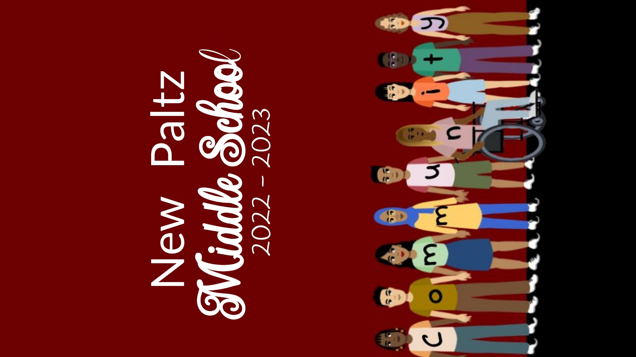
2023-2024 Yearbook Design Contest!!!!
Have your original artwork featured on the cover (or back cover) of the yearbook!
Designs must:
- be drawn on standard 8.5 x 11 printer paper.
- be BOLD, whether in black and white or color.
- be original (not copied from another source).
- represent this school year in a positive, unique way.
- be submitted to kconrad@newpaltz.k12.ny.us
The winners will receive a FREE yearbook and their name and picture featured in this year’s edition!!!
We are looking for Front Cover Winner, Back Cover Winner, Feature Artist Winner, Front Page Winner and Back Page Winner, so many opportunities to be featured!

Deadline for submission December 15th

